Part of: Relational Databases & Tables:
- To retrieve specific data from the E-Commerce database using SQL SELECT queries with conditions.

Table Used: Products

Retrieve all products from the products table whose price is greater than ₹50,000.

SQL Query-
SELECT * FROM products WHERE price > 50000;
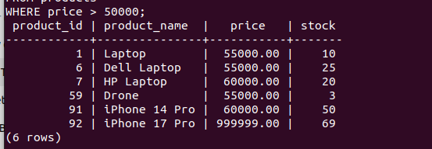

- Explanation:
-This query selects all records from the products table.
-The WHERE clause is used to filter and display only those products whose price is greater than ₹50,000.

- Assumption:
Products priced above ₹50,000 are considered high-value products.

